Geometry: Unit 2, Lesson 3
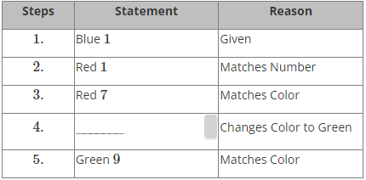
- The table shows an incomplete series of steps for a game of UNO. What is the statement for Step 4 for the game of UNO?

Wild

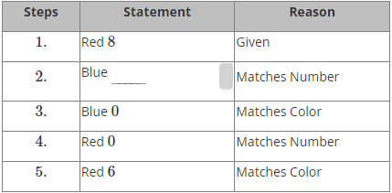
- The table shows an incomplete series of steps for a game of UNO. What is the correct value for Step 2 for the game of UNO?

8

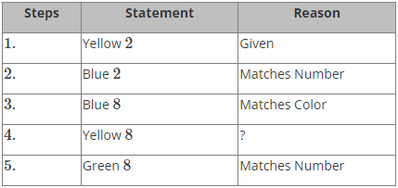
- The table shows an incomplete series of steps for a game of UNO. What is the statement for Step 4 for the game of UNO?

Matches Number

